**Steps to running ANOVA in IS**

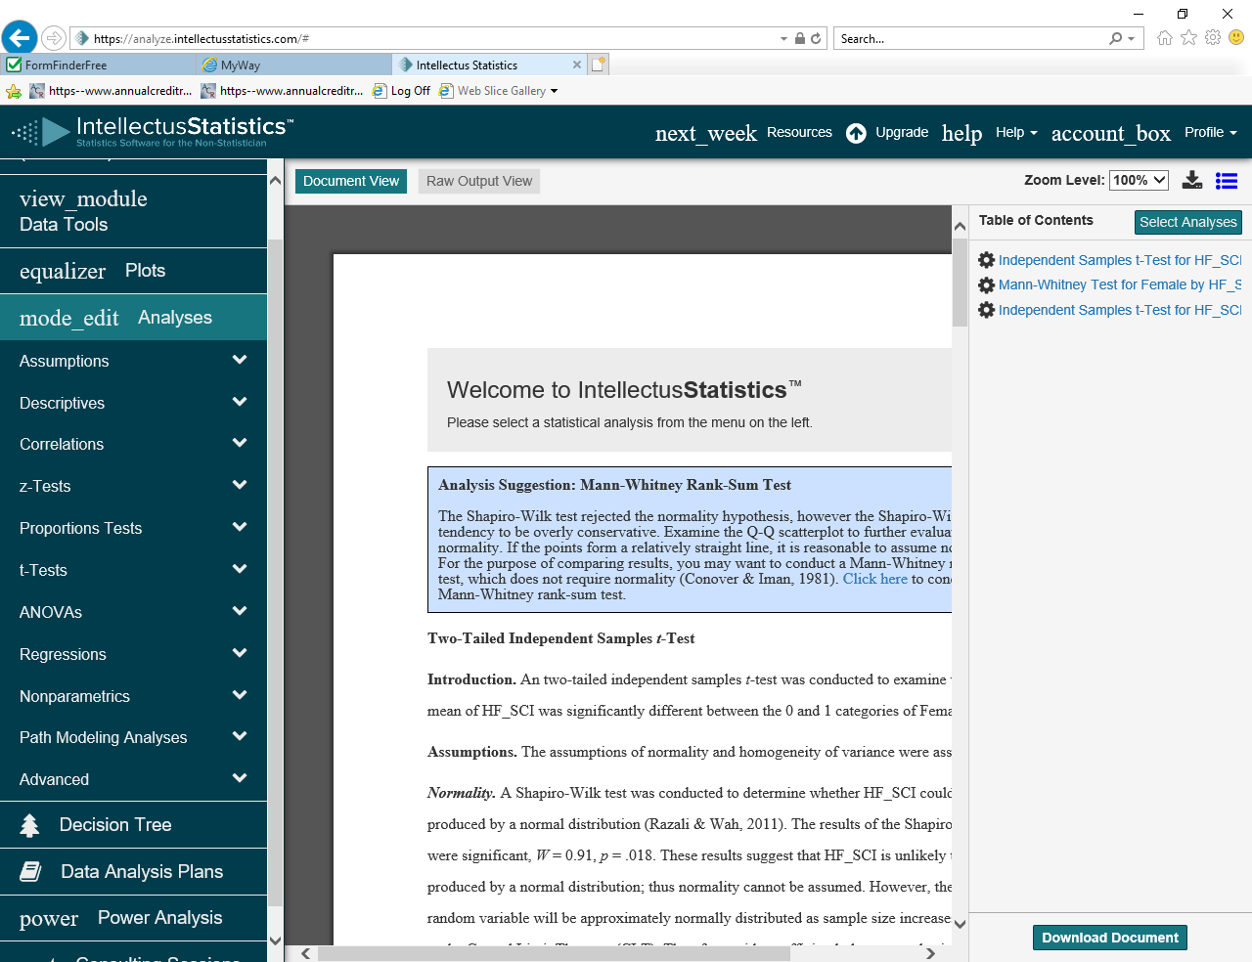

**One way ANOVA**

1. Select mode_edit Analysis
2. Begin by selecting ANOVA

and ANOVA within this menu

1. Identify your independent and dependent variables

When ready click on the +Add/Modify

Use “down” arrow on the right hand side to see all possible variables

With the variable you want marked click on ‘add dependent variable’

Repeat the process for selecting your independent variable

We are not doing any interactions so you can ignore these.

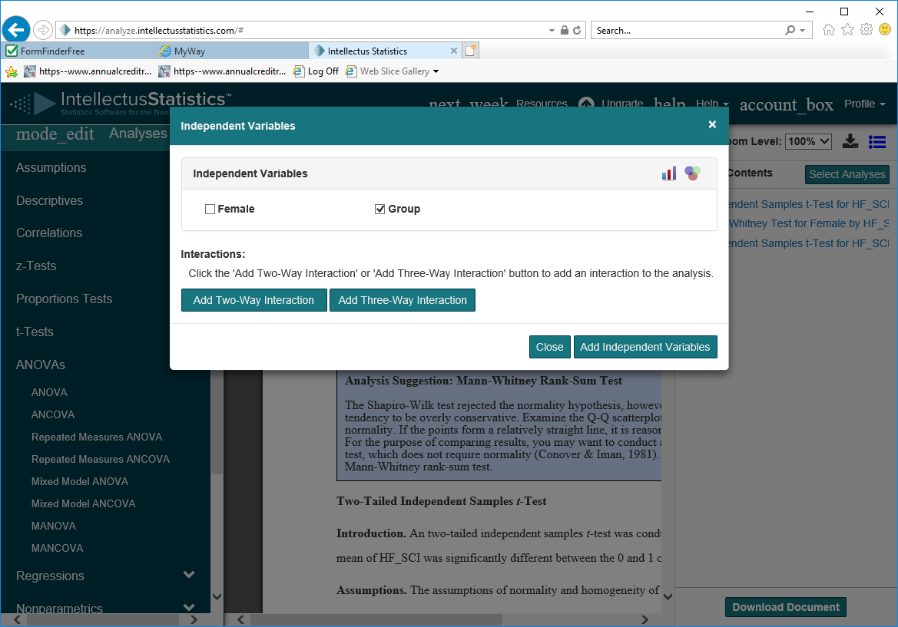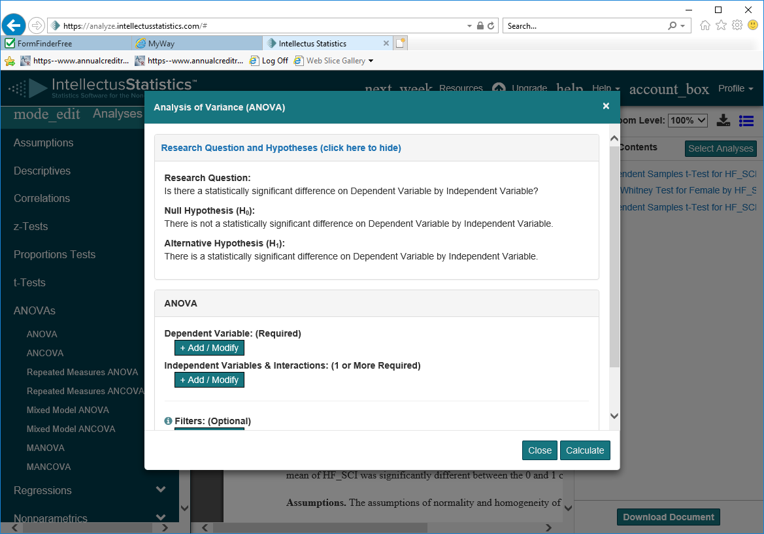  
Once both the IV and DV are entered view the research questions and hypothesis to check if OK

Extra help and information can be found by hitting the tutorial button

Hit ‘calculate’

1. View the raw output view (choose button on top)
2. View the results.

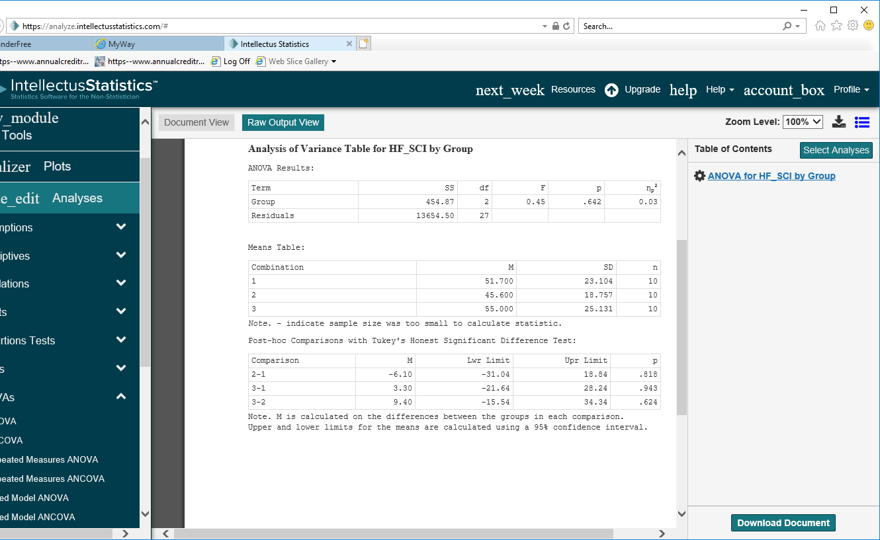

**Important Note!** All an ANOVA test can tell you is whether there are statistically significant differences *somewhere* in the data as a whole. It cannot tell you *just where* those differences lie. The ANOVA itself can only tell you that at least *one* group in there is different from *some other* group in there …but not which ones. Therefore IF (and only if) your Between Groups pvalue falls below 0.05, then you will want to run a post-hoc comparison.

1. View the document view to see example of write up